BIRLA INSTITUTE OF TECHNOLOGY & SCIENCE, PILANI
WORK-INTEGRATED LEARNING PROGRAMMES DIVISION
BITS-WIPRO Collaborative Program
B Tech (Information Systems)_WIMS Batch
Third Semester 2018-2019
.

Assignment On:
.

INSTAGRAM

By-

➢ Chetan Singh 2017HW86656
➢ Md. Saif Akhtar 2017HW86___
➢ Ashutosh Padhi 2017HW86512
➢ Anurag Patil 2017HW86590
➢ Gola Shrikant 2017HW86610
➢ Kota Amarendra Kumar 2017HW86617

.
Problem definition:
……………………………………………………………………….
> Today all the works and the advertisements are going through the social sites, so we have worked over the one named as INSTAGRAM.
> It is required to design of a user friendly automated design system. We have implemented a new concept into this.

Purpose:
……………………………………………………………………….
>This document gives the detailed about how we can share the data with “#Tag” foreign key.
> It can be utilize by the developers so that a person shared the same details without opening another app through the foreign key.

SRS of Instagram Project
…………………………………………..

• Instagram database contains data of multiple users.
• Each User has a unique ID(IN-id), name(IN-name) and mobile number (IN-contact)
• Every Instagram user has one management team.
• The management team manage different department where each department has its own unique department id (D-id) and department name (D-name).
• Each user has staff/space for pictures and videos.
• Every staff has their id where user can see the details.
• Every department has request committee through which he manages to send request to others.
• User has user id(IN-id) , user name (IN-name), DOB(IN-dob), Standard(IN-standard) and contact number (IN-contact).
• Each user can see/gather information about other members.

ER-Diagram
…………………………………………

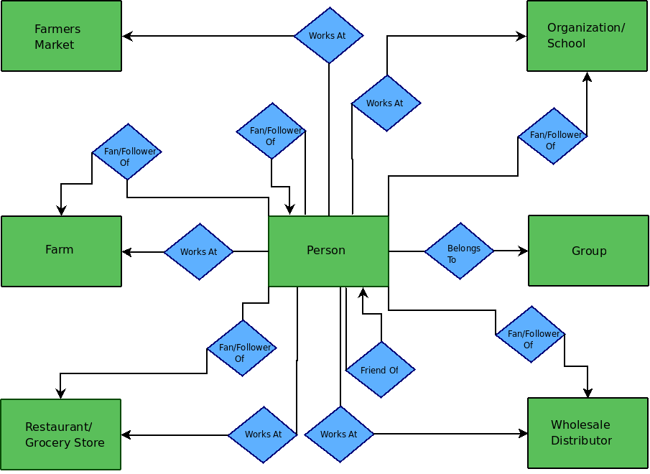

Sequential Diagram of Instagram
…………………………………………….

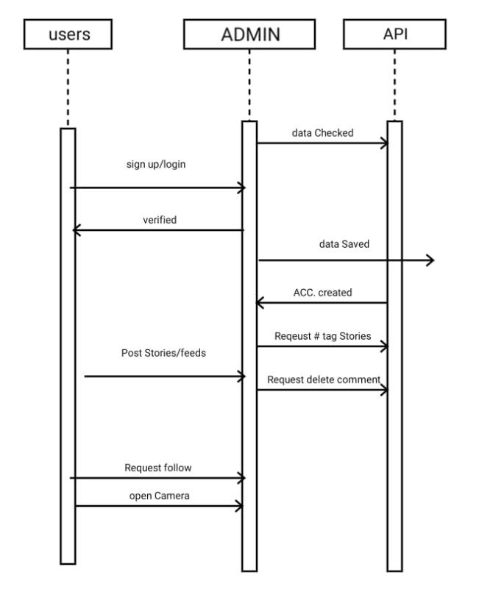
Database Schema of Instagram’s Photo(Sample)
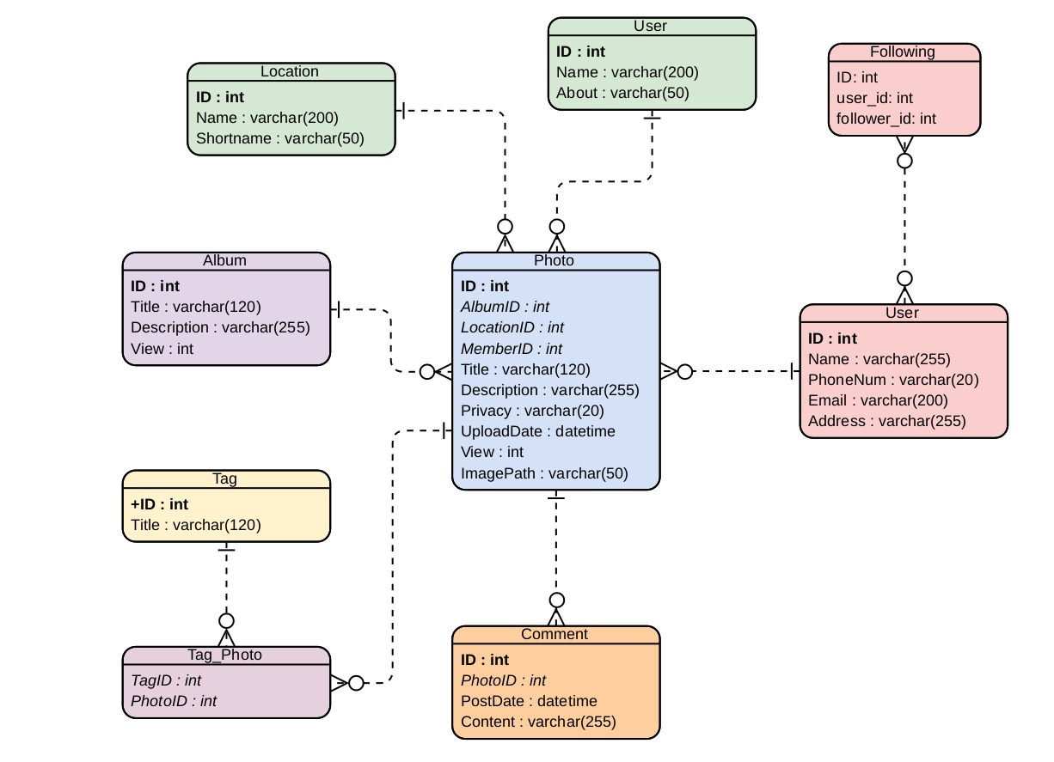
…………………………………………….

Customer Tables
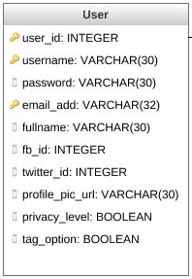
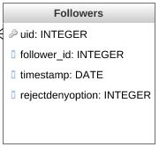
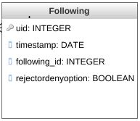
…………………………………………….
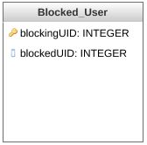
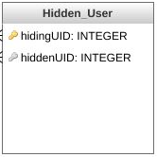

Simple Queries in Data Base
…………………………………………
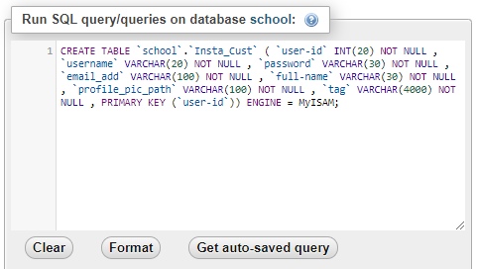
- Create Table for Instagram Customers:
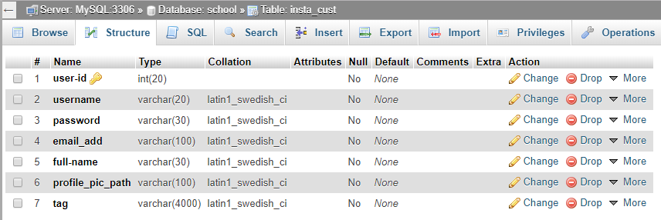
- Creating Table for Facebook User:
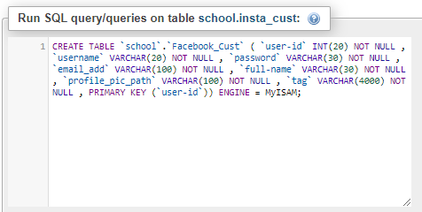

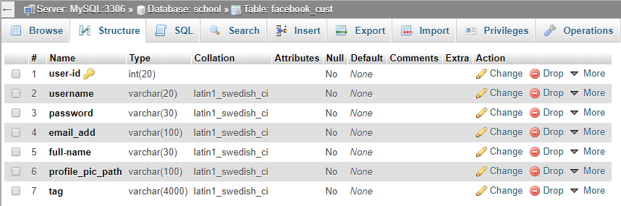

- Inserting data into Tag field in ‘Insta_Customer’:
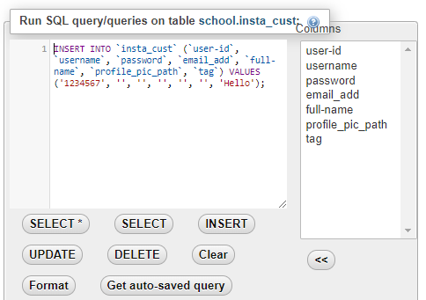

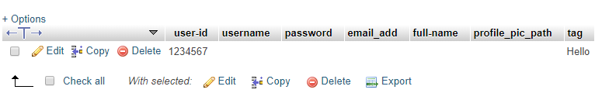
Entries Updated in Instagram:

- PLSQL query to transfer data from ‘Insta_Customer’ to ‘Facebook_Customer’:

- First we need to have the data(mentioned into TAG field) of the first table ‘Cust_ID’ into a variable in PLSQL.
- Then move it through the process and insert/assign it to the ‘Tag’ field into ‘string’.
- After once get the value of Tag into String, assign it again to the ‘Tag’ field of ‘Facebook_Cust’ table.

DECLARE
Cust_id VARCHAR(30);
string VARCHAR(30);
BEGIN
SELECT `tag` FROM `insta_cust` WHERE `user-id`=’1234567’ FOR UPDATE OF string;
IF user-id != NULL THEN
UPDATE `tag` IN `facebook_cust` SET = string
WHERE user-id = `1234567`;
END IF;
COMMIT;
END;
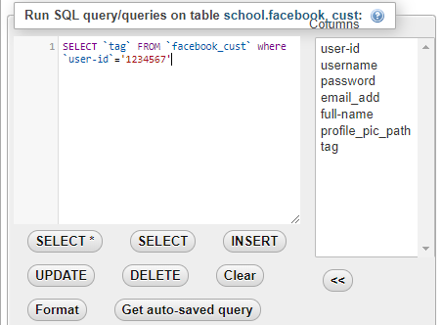
- Showing data submitted successfully to ‘Facebook_Customer’:
